-: Practical – 1 :-
1. Vending machine (VendingMachine.java, main in this file)
(a) Define an enum Coin with constants ONE, TWO, FIVE, TEN.
(b) In main, set a snack price of 15 and a running total of 0; create a Scanner.
(c) Loop: read a coin name, use a switch expression to convert the Coin to its value
(ONE→1, TWO→2, FIVE→5, TEN→10), add it to the total, and print the total so
far.
(d) Stop the loop once the total reaches 15 or more.
(e) Print the change to return (total − 15).

Source code :-
import java.util.Scanner;

enum Coin {
ONE, TWO, FIVE, TEN
}
public class VendingMachine {
public static void main(String[] args) {
int price = 15;
int total = 0;
Scanner sc = new Scanner(System.in);
while (total < price) {
System.out.print("Enter coin (ONE, TWO, FIVE, TEN): ");
Coin coin = Coin.valueOf(sc.next().toUpperCase());
int value = switch (coin) {
case ONE -> 1;
case TWO -> 2;
case FIVE -> 5;
case TEN -> 10;
};
total = total + value;
System.out.println("Total = " + total);
}
System.out.println("Change = " + (total - price));
sc.close();
}
}
Output :-

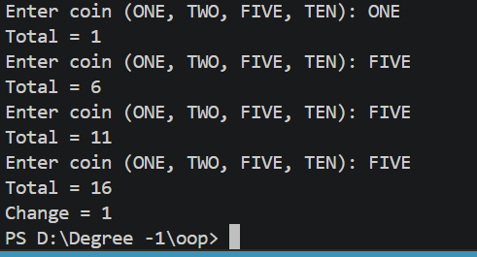
2. Toll booth (TollBooth.java, main in this file)
(a) Define a record Vehicle(String number, String type).
(b) In main, keep a running toll total and three counters (bike, car, truck).
(c) Loop until the user types “done” for the number: build a Vehicle, use a switch
expression on its type for the toll (bike→20, car→50, truck→150), add to the total,
and increment that type’s counter.
(d) After the loop, print the total toll and the type with the highest count.

Source Code :-
import java.util.Scanner;

record Vehicle(String number, String type) {}
public class TollBooth {

public static void main(String[] args) {
Scanner sc = new Scanner(System.in);

int totalToll = 0;
int bike = 0, car = 0, truck = 0;
while (true) {
System.out.print("Enter Vehicle Number (or done): ");
String number = sc.next();

if (number.equalsIgnoreCase("done")) {
break;
}

System.out.print("Enter Vehicle Type (bike/car/truck): ");
String type = sc.next().toLowerCase();

Vehicle v = new Vehicle(number, type);
int toll = switch (v.type()) {
case "bike" -> 20;
case "car" -> 50;
case "truck" -> 150;
default -> 0;
};
totalToll += toll;
switch (v.type()) {
case "bike" -> bike++;
case "car" -> car++;
case "truck" -> truck++;
}
}
System.out.println("Total Toll = " + totalToll);
if (bike >= car && bike >= truck) {
System.out.println("Highest Count = Bike");
} else if (car >= bike && car >= truck) {
System.out.println("Highest Count = Car");
} else {
System.out.println("Highest Count = Truck");
}
sc.close();
}
}

Output :-

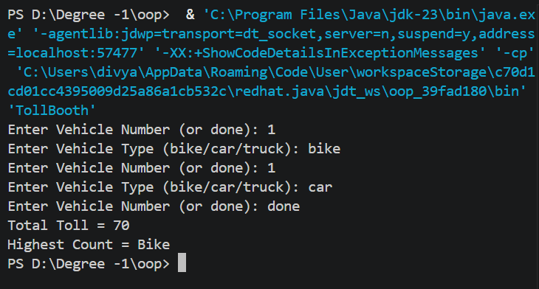
Part – B :-
1. Set up your environment: open the project in GitHub Codespaces (or install JDK 17+ and
an IDE locally), and create a private GitHub repository named oop-minibank-<rollno>;
add the faculty as a collaborator.
2. Create a public class named MiniBank that contains the main method.
3. Define a record named BankInfo with two String fields, name and branch (a record is a
short, read-only class; Java auto-generates its constructor and field accessors). Print one
BankInfo object as the application header.
4. Define an enum named MenuOption with the constants OPEN_ACCOUNT, DEPOSIT,
WITHDRAW, TRANSFER and EXIT — these are the actions MiniBank will offer.
5. Display the numbered menu to the user and read the chosen number with a Scanner.
6. Use a switch expression on the choice to print a short placeholder for that option (for
example, “Deposit — to be implemented in a later lab”). Keep showing the menu in a
loop until the user selects EXIT, then print a goodbye message.

Source Code :-
import java.util.Scanner;

record BankInfo(String name, String branch) {}

enum MenuOption {
OPEN_ACCOUNT,
DEPOSIT,
WITHDRAW,
TRANSFER,
EXIT
}

public class MiniBank {

public static void main(String[] args) {

Scanner sc = new Scanner(System.in);
BankInfo bank = new BankInfo("Mini Bank", "Ahmedabad");
int choice;
do {

System.out.println("\n========================");
System.out.println(bank.name() + " - " + bank.branch());
System.out.println("========================");
System.out.println("1. Open Account");
System.out.println("2. Deposit");
System.out.println("3. Withdraw");
System.out.println("4. Transfer");
System.out.println("5. Exit");

System.out.print("Enter your choice: ");
choice = sc.nextInt();

MenuOption option = switch (choice) {
case 1 -> MenuOption.OPEN_ACCOUNT;
case 2 -> MenuOption.DEPOSIT;
case 3 -> MenuOption.WITHDRAW;
case 4 -> MenuOption.TRANSFER;
default -> MenuOption.EXIT;
};

switch (option) {

case OPEN_ACCOUNT ->
System.out.println("Open Account - To be implemented later");

case DEPOSIT ->
System.out.println("Deposit - To be implemented later");

case WITHDRAW ->
System.out.println("Withdraw - To be implemented later");

case TRANSFER ->
System.out.println("Transfer - To be implemented later");

case EXIT ->
System.out.println("Thank You! Goodbye.");
}

} while (choice != 5);
sc.close();
}
}

Output :-

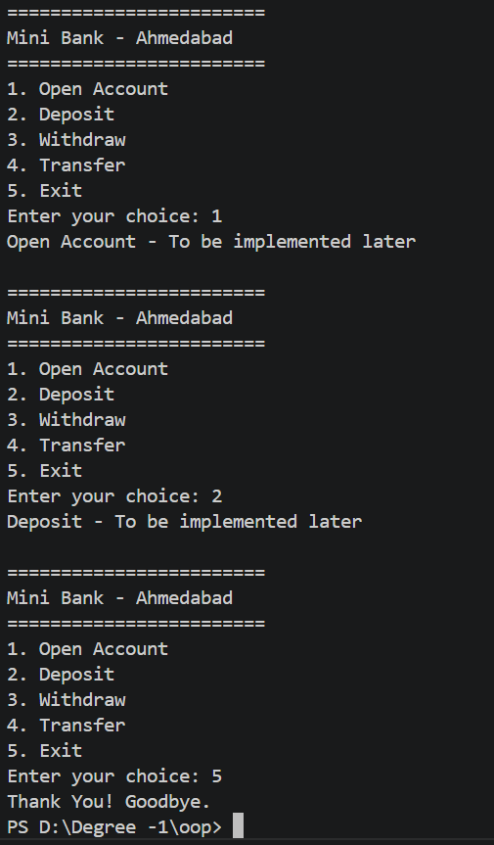

-: Practical -2 :-
1. Smart thermostat (Thermostat.java, main in this file)
(a) Create class Thermostat with private String location, private int temperature, private
static final int MIN=16 and MAX=30, and private static int activeCount=0.
(b) Constructor(location, startTemp): store location; set temperature to startTemp if it is
within MIN..MAX else 22; increment activeCount.
(c) Constructor(location): chain with this(location, 22).
(d) raise(): if temperature < MAX add 1, else print “Already at maximum (30)”.
(e) lower(): if temperature > MIN subtract 1, else print “Already at minimum (16)”.
(f) Add getTemperature() (no setter) and static getActiveCount().
(g) In main: create two thermostats, call raise() 10 times then lower() 20 times in loops
(printing the temperature each time), then print getActiveCount().

Source code :-
class Thermostat {

private String location;
private int temperature;

private static final int MIN = 16;
private static final int MAX = 30;

private static int activeCount = 0;

public Thermostat(String location, int startTemp) {

this.location = location;

if(startTemp >= MIN && startTemp <= MAX) {
temperature = startTemp;
}
else {
temperature = 22;
}
activeCount++;
public Thermostat(String location) {
this(location,22);
}
public void raise() {

if(temperature < MAX) {
temperature++;
}
else {
System.out.println("Already at maximum (30)");
}
}
public void lower() {
if(temperature > MIN) {
temperature--;
}
else {
System.out.println("Already at minimum (16)");
}
}
public int getTemperature() {
return temperature;
}
public static int getActiveCount() {
return activeCount;
}
}

Output :-

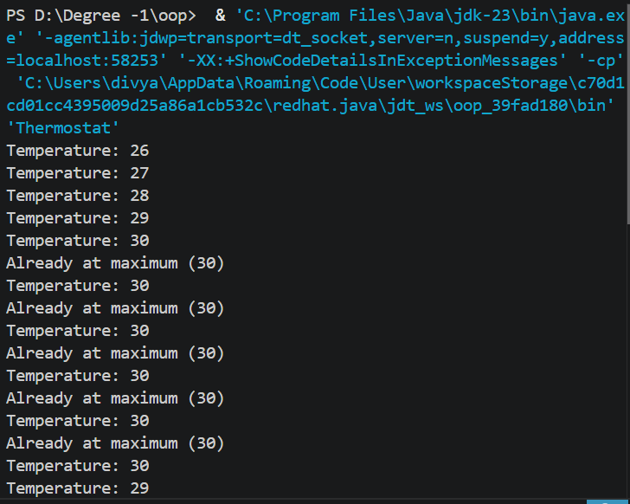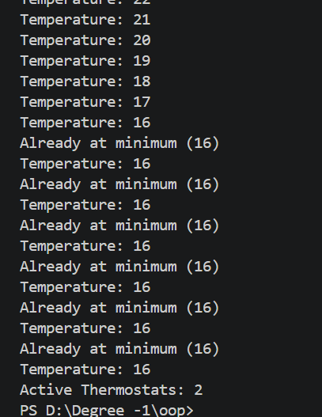
2. Cinema show (CinemaShow.java, main in this file)
(a) Create class CinemaShow with private String title, private int seatsAvailable, private
final int capacity, and private static int totalBooked=0.
(b) Constructor(title, capacity): set both and seatsAvailable = capacity.
Constructor(title): chain with this(title, 100).
(c) book(int n): if n ≤ seatsAvailable, reduce seatsAvailable by n, add n to totalBooked,
return true; else return false unchanged.
(d) cancel(int n): increase seatsAvailable by n but never above capacity.
(e) Add getSeatsAvailable() and static getTotalBooked().
(f) In main: run a sequence of book and cancel calls, printing the result and seats after
each, then print getTotalBooked().
Expected output: booking more than available prints false and leaves seats
unchanged; totalBooked equals the successful bookings.

Source Code :-
public class CinemaShow {

private String title;
private int seatsAvailable;
private final int capacity;
private static int totalBooked = 0;

CinemaShow(String title, int capacity) {
this.title = title;
this.capacity = capacity;
this.seatsAvailable = capacity;
}

CinemaShow(String title) {
this(title, 100);
}

boolean book(int n) {
if (n <= seatsAvailable) {
seatsAvailable = seatsAvailable - n;
totalBooked = totalBooked + n;
return true;
}
return false;
}

void cancel(int n) {
seatsAvailable = seatsAvailable + n;

if (seatsAvailable > capacity) {
seatsAvailable = capacity;
}
}

int getSeatsAvailable() {
return seatsAvailable;
}

static int getTotalBooked() {
return totalBooked;
}

public static void main(String[] args) {

CinemaShow show = new CinemaShow("Avengers", 50);

System.out.println(show.book(20));
System.out.println("Seats: " + show.getSeatsAvailable());

System.out.println(show.book(40));
System.out.println("Seats: " + show.getSeatsAvailable());

show.cancel(10);
System.out.println("Seats: " + show.getSeatsAvailable());

System.out.println(show.book(30));
System.out.println("Seats: " + show.getSeatsAvailable());

System.out.println("Total Booked: " + CinemaShow.getTotalBooked());
}
}
Output :-
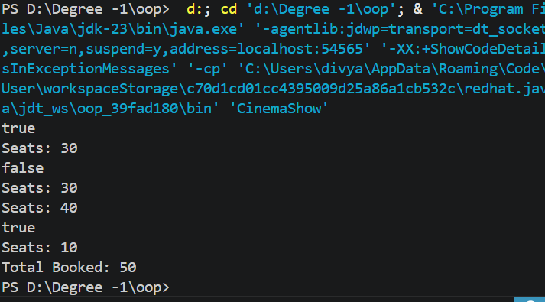

Part B — Project Work (Hour 2): MiniBank
1. Create a class named Customer with private fields name, email and mobile (all String)
and a private final field customerId (String). Use a private static long field
customerCounter and a private static method generateCustomerId() to create ids such as
“CUST101”. Add a constructor and public getter methods.
2. Create a class named Account with private fields: a final String accountNumber, a String
ownerName, a long balance (whole rupees) and a boolean active. Generate
accountNumber with a private static counter (for example “AC0001”).
3. Add two constructors to Account: one taking ownerName and an opening balance; one
taking only ownerName that calls the first using this(ownerName, 0).
4. Add a public method deposit(long amount) that adds amount to balance. Add a public
method withdraw(long amount) that subtracts amount and returns true when the balance
is sufficient, otherwise returns false without changing the balance. Add getter methods.
Do NOT add a public setter for balance.
5. In main, create three Account objects inside an Account[] array, perform a few deposits
and withdrawals, and print each balance.

Source code :-
class Customer {

private String name;
private String email;
private String mobile;
private final String customerId;

private static int customerCounter = 101;

private static String generateCustomerId() {
return "CUST" + customerCounter++;
}

Customer(String name, String email, String mobile) {
this.name = name;
this.email = email;
this.mobile = mobile;
this.customerId = generateCustomerId();
}

public String getCustomerId() {
return customerId;
}
}

class Account {

private final String accountNumber;
private String ownerName;
private long balance;
private boolean active;

private static int counter = 1;

private static String generateAccountNumber() {
return "AC000" + counter++;
}

Account(String ownerName, long balance) {
this.accountNumber = generateAccountNumber();
this.ownerName = ownerName;
this.balance = balance;
active = true;
}

Account(String ownerName) {
this(ownerName, 0);
}

public void deposit(long amount) {
balance = balance + amount;
}

public boolean withdraw(long amount) {
if (balance >= amount) {
balance = balance - amount;
return true;
}
return false;
}

public String getAccountNumber() {
return accountNumber;
}

public String getOwnerName() {
return ownerName;
}

public long getBalance() {
return balance;
}
}

public class BankSystem {

public static void main(String[] args) {

Customer c1 = new Customer("Rahul", "rahul@gmail.com", "9876543210");

Account[] a = new Account[3];

a[0] = new Account("Rahul", 1000);
a[1] = new Account("Priya");
a[2] = new Account("Amit", 500);

a[0].deposit(500);
a[1].deposit(1000);
a[2].withdraw(200);

for (int i = 0; i < 3; i++) {
System.out.println("Account No : " + a[i].getAccountNumber());
System.out.println("Owner : " + a[i].getOwnerName());
System.out.println("Balance : " + a[i].getBalance());
System.out.println();
}
}
}

Output :-

